

NOVAC TECHNOLOGY SOLUTIONS

User Manual

Document Version No.: 1.00

Revision History
Version No | Reason For Changes | Author | Approver
0.01 | Draft | Ravi
1.00 | Reviewed & Approved the User Manual | Ravi | NIJANTHAN PL

Table of Contents
1. Introduction 4
2. Policy schedule through website 4

Introduction

This user manual explains about the option to Insured person to download the Policy schedule document on the website.

Changes in CTPL Policies

- As per the new requirement now Insured Person can able to download the policy schedule through Philippines website.

Path: URL -> http://192.169.1.91/Sgiphil_Portal/Models/PolicyDownload.aspx

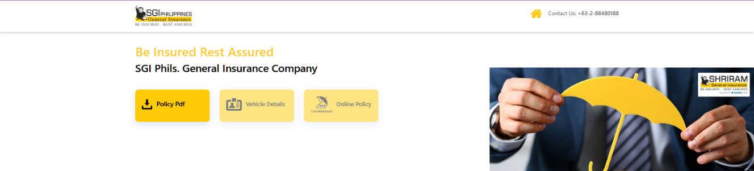
Navigate to SgiPhil website, and click download policy pdf button, it redirect to Download policy Pdf page.
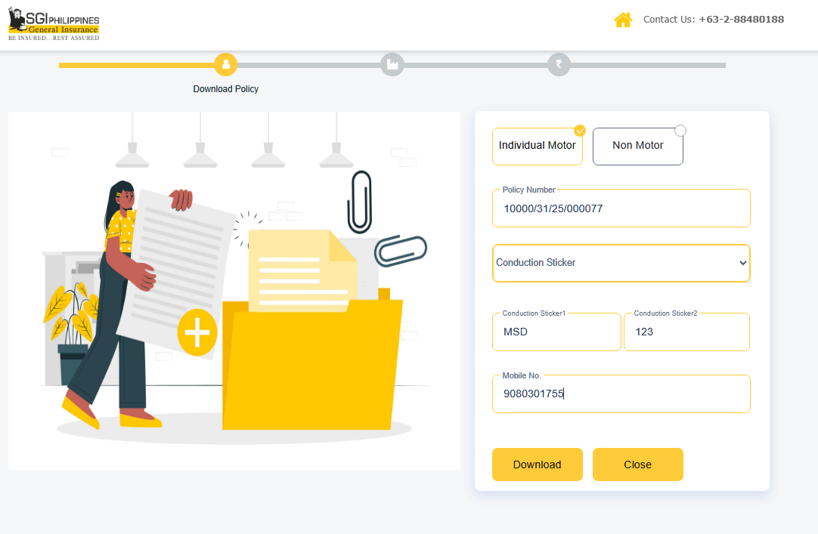
After enter all details, clicking on Download button , system download the respected Policy.

